LAB 9

Name: Disha Agarwal Registration number: 210905412 Branch: CSE A

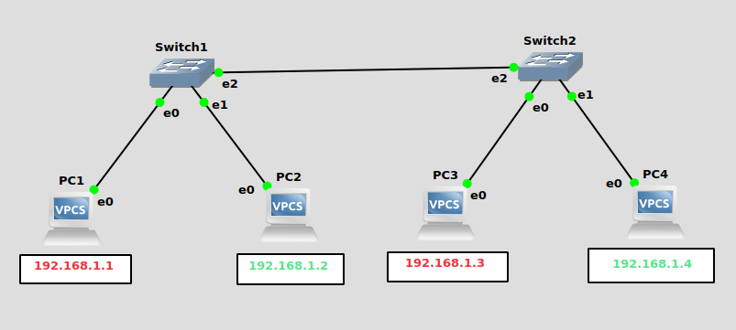
DESIGN 1

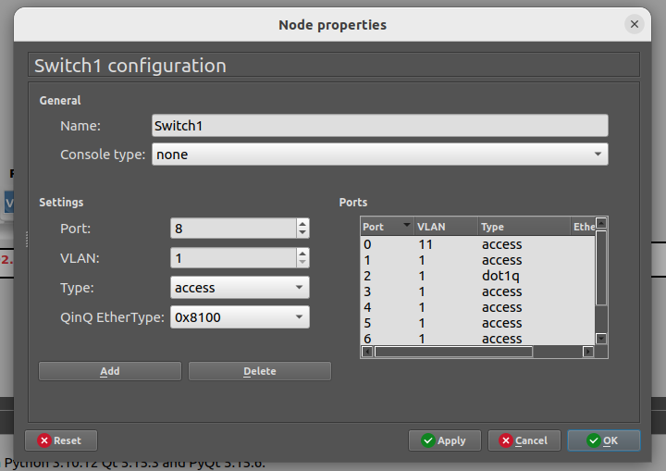
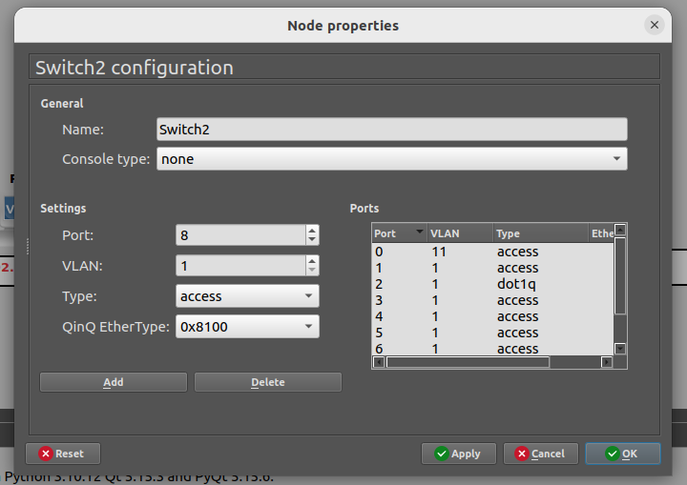

DESIGN 2

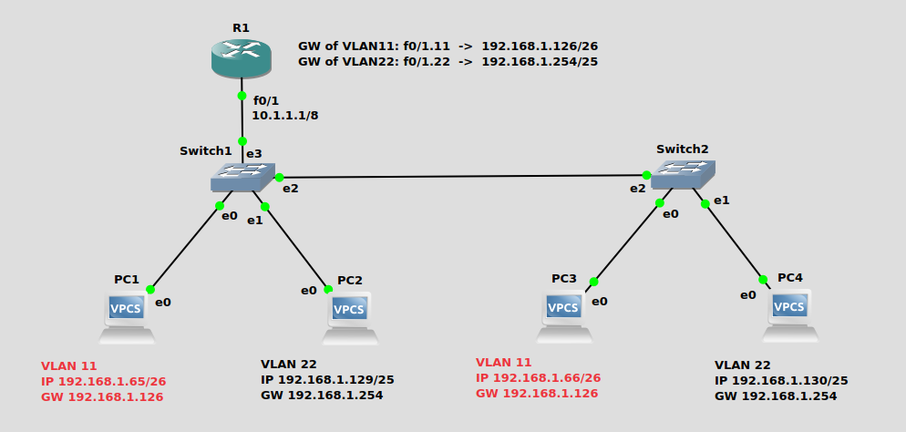

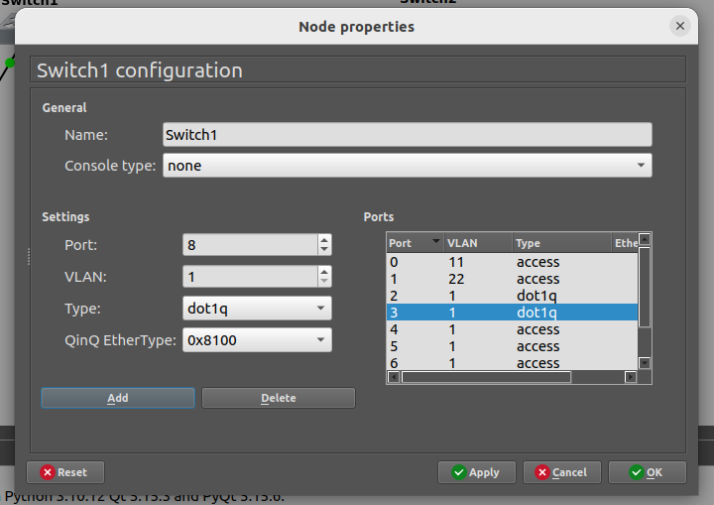
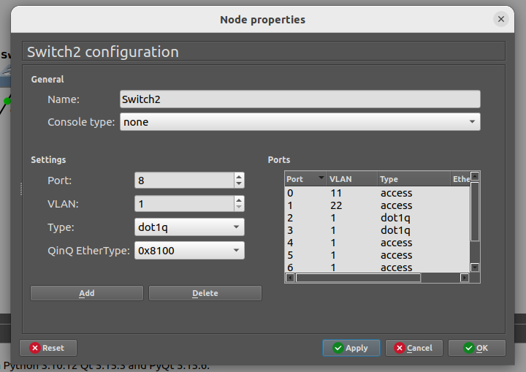

R1:
conf t
int f0/1
ip address 10.1.1.1 255.0.0.0
no shut
exit
int f0/1.11
encapsulation dot1q 11
ip address 192.168.1.126 255.255.255.192
no shut
exit
int f0/1.22
encapsulation dot1q 22
ip address 192.168.1.254 255.255.255.128
no shut
exit
ip dhcp pool VLAN11
network 192.168.1.64 255.255.255.192
default-router 192.168.1.126
exit
ip dhcp pool VLAN22
network 192.168.1.128 255.255.255.128
default-router 192.168.1.254
exit
do wr
exit

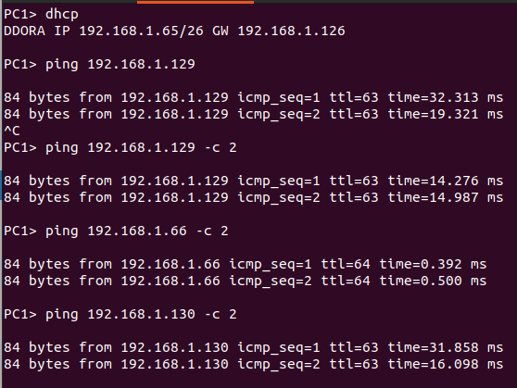

DESIGN 3
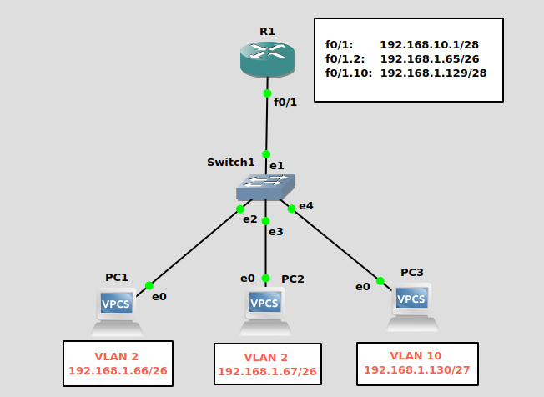
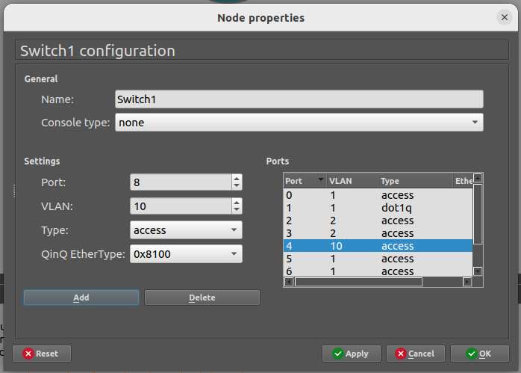

R1:
conf t
int f0/1
ip address 192.168.10.1 255.255.255.240
no shut
exit
int f0/1.2
encapsulation dot1q 2
ip address 192.168.1.65 255.255.255.192
no shut
exit
int f0/1.10
encapsulation dot1q 10
ip address 192.168.1.129 255.255.255.224
no shut
exit
do wr
exit

